STAGE | STAGE DETAILS | Stage Start Location | Sign  On Time | Start Time | Distance | Stage Finish Location | Expected  Finish
Stage 1  Wednesday  5th Sept | Kilkenny (SHC) – Danesfort -Bennettsbridge –Thomastown - Graiguenamanagh- Goresbridge – Royal Oak – Paulstown – Gowran | Spring Hill Court Hotel (SHC) | 1pm to 3pm | 16:45pm | 70km | Gowran | 6.30pm
Stage 2  Thursday  6th Sept | Castlecomer (Discovery Park) Ballyraggett – Firoda – Castlecomer – Coolcullen – Rossmore – Castlecomer | Castlecomer Discovery Park | 11am | 12pm | 75km | Castlecomer | 2pm
Stage 3  Friday  7th Sept | Kilkenny (SHC) – Paulstown - Leighlinbridge – Bagenalstown - Borris – Ballymurphy – Kiltealy – Bunclody – Kildavin – Ballon - Mount Leinster | SHC | 11am | 12pm | 112km | Nine Stones Mount Leinster | 3pm
Stage 4  Saturday  8th Sept | Individual Time Trial  Tullaroan - Ballybay | Tullaroan GAA Club | n/a | 10am | 6.4km | Ballybay | 12pm
Stage 5  Saturday  8th Sept | Kilkenny  The Parade – Nuncio Road – Waterford Road – Upper Patrick Street | Kilkenny Castle | 4pm to 5pm | 6:30pm | 1hour | Kilkenny Castle | 7:30pm
Stage 6  Sunday  9th Sept | Kilkenny – Kells – Dunamaggin – Knocktopher – Thomastown – Inistioge – Woodstock – Thomastown – Paulstown - Kilkenny | SHC | 10.30am | 11.30am | 88km | Kilkenny Castle | 2pm

STAGE | STAGE DETAILS  https://ridewithgps.com/routes/27569409 | START  TIME | FINISH  TIME
Stage 1 – Wed  5th Sept | Kilkenny (SHC) – Danesfort -Bennettsbridge –Thomastown - Graiguenamanagh -  Goresbridge – Royal Oak – Paulstown – Gowran | 4:45pm | 6:30pm
- Roll out from Springhill Court Hotel.  - Turning Left out of hotel & neutralised 1km  - Racing starts @ Rugby Club  - Race goes through towns listed with 1x QOH @ 26.4KM  - Race finishes in Gowran (directly after St. Mary's Collegiate Church).  Team cars diverted off the R702 down by the church to park in an orderly fashion.  Riders proceed along the R702, taking the 2nd exit on a mini first roundabout and then left onto the R448 to finish just after St. Mary’s Church.  Space for the Stagecoaster at the garage (with permission). | 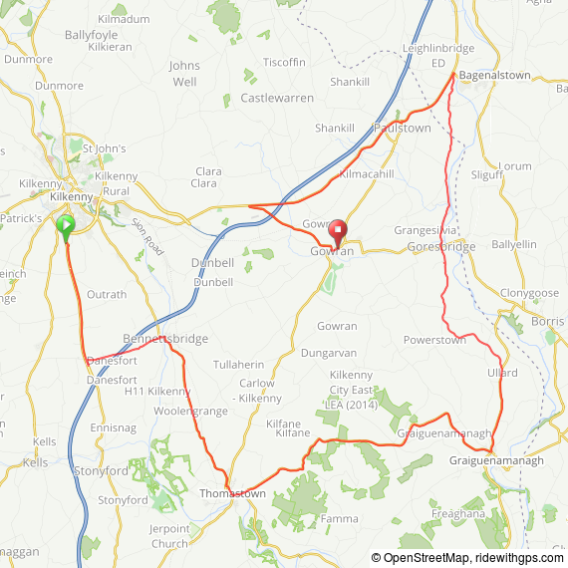  FINISH of STAGE 1  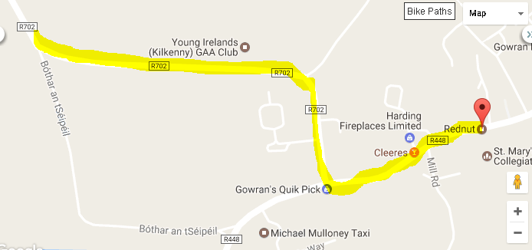  FINSIH  RIDERS  RACE CARS
STAGE | STAGE DETAILS  https://ridewithgps.com/routes/27569464 | START  TIME | FINISH  TIME
Stage 2 – Thurs  6th Sept | Castlecomer - Ballyraggett – Firoda – Castlecomer – Coolcullen – Rossmore – Castlecomer | 12pm | 2pm
- Roll out from Castlecomer Discovery Park  - Race is neutralised through the town for 2km.  - Race starts at 100km sign N78  - Race goes through towns above looping through Castlecomer to take in Coolcullen & Rossmore  - Race finishes in Castlecomer at Wandesford School | 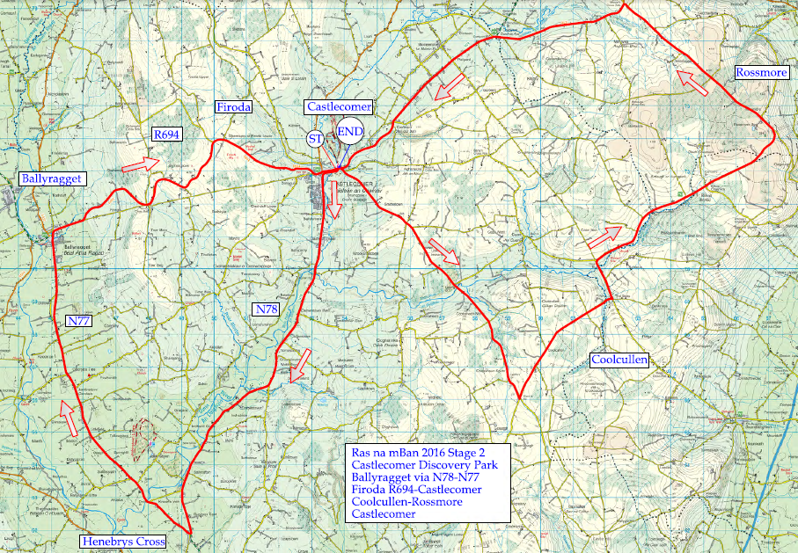

STAGE | STAGE DETAILS  https://ridewithgps.com/routes/27569489 | START  TIME | FINISH  TIME
Stage 3 – Fri  7th Sept | Kilkenny (SHC) – Paulstown - Leighlinbridge – Bagenalstown - Borris – Ballymurphy – Kiltealy – Bunclody – Kildavin – Ballon - Mount Leinster | 12pm | 3pm
- Roll out from the Springhill Court Hotel  - Race neutralised 4km  - Race starts @ Blue Bike Lane Sign on LHS  - Race goes through towns listed  - Race finishes on Mount Leinster @ Nine Stones | 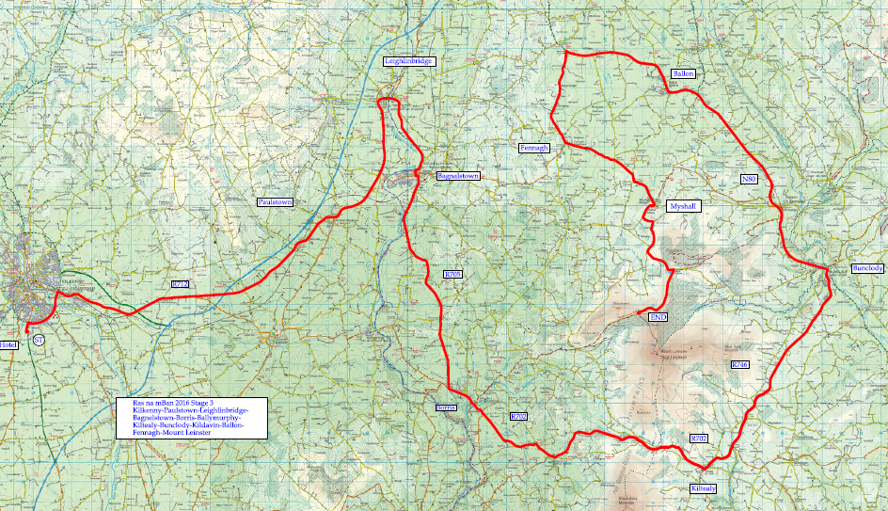

STAGE | STAGE DETAILS  https://ridewithgps.com/routes/27569519 | START  TIME | FINISH  TIME
Stage 4 – Sat  8th Sept | Individual Time Trial  Tullaroan - Ballybay | 10am | 12pm
- Time Trial starts at entrance to Tullaroan GAA club  - Riders go off in one minute intervals  - Time trial distance is: 6.4km  - Alternate route for rider's descent/team car access | Time Trial route:  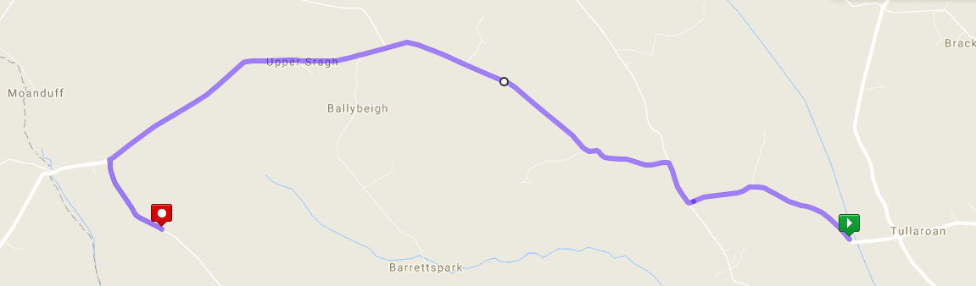  Alternate route:  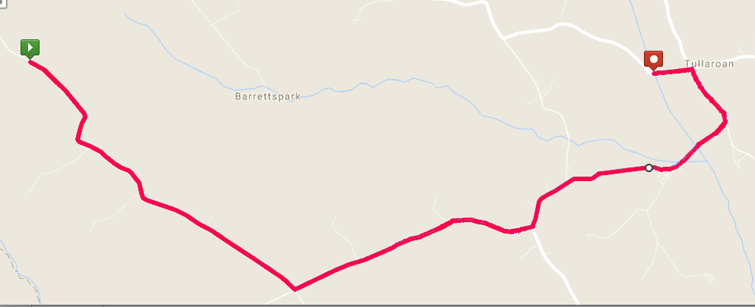

STAGE | STAGE DETAILS  https://ridewithgps.com/routes/27569533 | START  TIME | FINISH  TIME
Stage 5 – Sat  8th Sept | Criterium Kilkenny | 6:30pm | 7:30pm
- Race starts on The Parade at Kilkenny Castle  - Race circuit is 2km  - Riders race for 1 hour  - Race finishes on The Parade at Kilkenny Castle. | 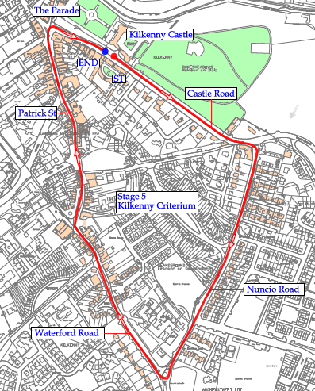

STAGE | STAGE DETAILS  https://ridewithgps.com/routes/27569427 | START  TIME | FINISH  TIME
Stage 6  Sun 9th Sept | Kilkenny – Kells – Dunamaggin – Knocktopher – Thomastown – Inistioge – Woodstock – Thomastown – Paulstown - Kilkenny Castle | 11:30am | 2pm
- Race starts from Springhill Court Hotel  - Race is neutralised for 1km  - Race goes through towns listed above including one ascent of Woodstock Hill.  - Race finish at Kilkenny Castle via Rose Inn St to finish at the Parade. | 